**Generate Payslip Module– Framework Design**

**Intent**

To provide flexible and extensible framework that allow adding different payslip calculation strategy in the Payslip generation module in the application.

To provide the abstract and generic payslip data that support extension.

**Motivation**

Every Human Resource Management System involve generating the payslip for employees and each system use different format to present the payslip information. Application developers need to develop the payslip generation module over an over to generate the payslip data for different payslip format. This framework module is design to provide the generic payslip data that can be used by different system.

**Participants (Design Pattern)**

1. Proxy *(IPayslipGenerator, PayslipGeneratorProxy, PayslipGenerator)*

* Point of access to the framework and generated the payslip data in hashmap format.
* User validation and varifcation.

1. Builder *(IPayslipDataBuilder, PayslipDataBuilder, PayslipDataDirector)*

* Responsible to build the generic Payslip data based on defined payslip calculation strategies for different employee type.
* Provide hook method for extension.

1. Visitor *(IEmployeePayslip, IPayslipVisitor, PayslipDataVisitor)*

* To link different payslip calculation strategies with payslip data builder for different type of employee.

1. Abstract factory *(IPayrollCalculationStrategyFactory, PayrollCalStraFactoryCommEmp, PayrollCalStraFactorySalEmp, PayrollCalStraFactorySalEmp)*

* Define collections of payslip calculation strategies for different employee type.

1. Prototype *(IPrototype, PayslipData)*

* Create cloneable payslip data.

1. Singleton (*PayslipGenerator)*

* Create thread safe payslip data generating engine.

1. Strategy (IEarningStrategy, EarningStrategySalEmpBonus, IDeductionStrategy, DeductionStrategyLeaveEmp, IBasicPayStrategy, BasicPayStrategyCommEmp, BasicPayStrategySalEmp, BasicPayStrategyHourEmp)

* Payslip calculation implementations.

**How to Use:**

|  |  |
| --- | --- |
| **Purpose** | **Solution** |
| To add new payroll calculation strategy | Step1.Create new strategy class and implement appropriate strategy interface (IEarningStrategy/ IDeductionStrategy/ IBasicPayStrategy)  Step2. Add the new class to appropriate strategy factory to apply the strategy. |
| Change payroll calculation strategy | Update Payslip calculation Strategy implementations. |
| Add new payslip info to payslip data | Wrap the PayslipData object after the generation or subclass the PayslipDataBuilder to override the buildHook() method. |
| Add new Employee Type | Step1. Implement IEmployeePayslip in new class  Step2. Add new Employee type to IPayslipVisitor.  Step3. Add implementation to PayslipDataVisitor to link with appropriate Payslip calculation Strategy factory. |
| Change Payslip calculation Strategy factory | Update PayslipDataVisitor to change the strategy factory. |
| Add new Payslip Writer | Implement IPaySlipWriter in new class. |

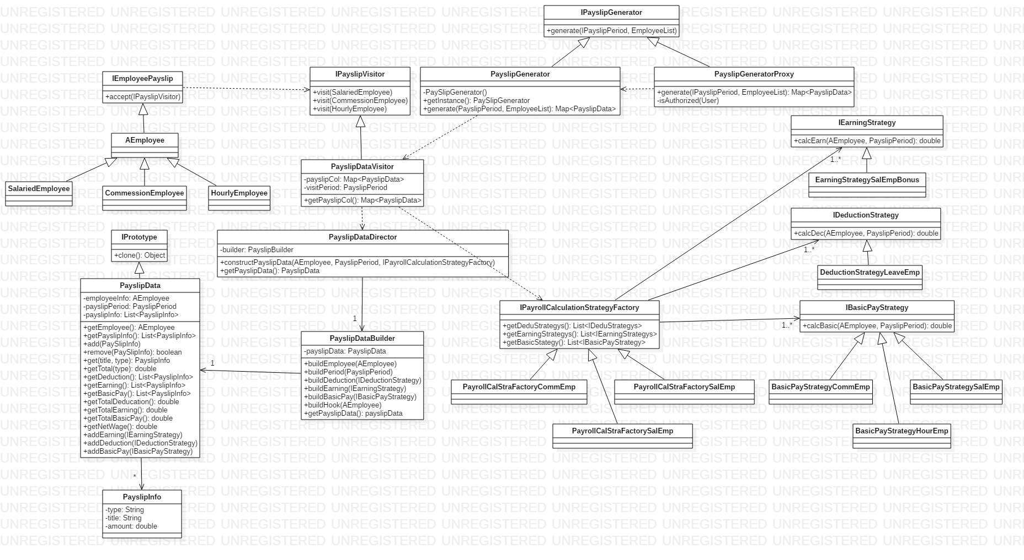**Structure:**